Checking Toleration in Qualys deployment

PODS are running on FMP node pool ,

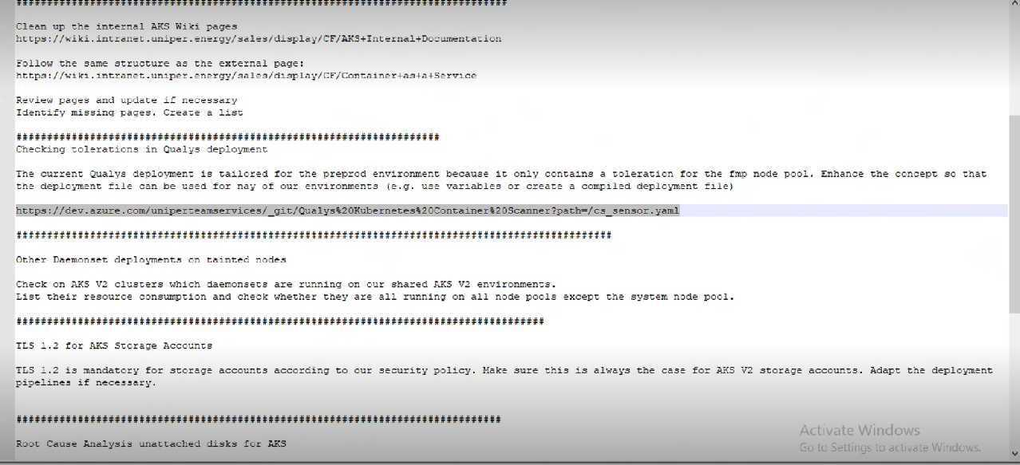

On pre-prod we have Fmp node – where Taint is applied , also qualys deployment is applied on this FMP node pool

Deamon set will create atleadt one pod on each node set .

There are 3 node pool

Fmp

System

Nodepool2

We shld deploy any application on system node

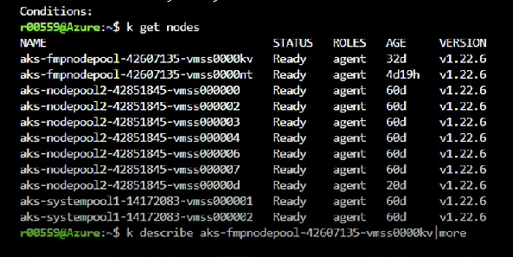

To define how many nodes using qulaysy agent :

